# Entity Relationship Diagram:

An **Entity-Relationship Diagram (ERD)** is a visual representation of the structure of a database, showing the relationships between various entities in that database. It is widely used in database design to conceptualize and communicate the database's logical structure before its actual implementation.

**Key Components of an ERD:**

1. **Entities**:
   * Represent the tables or objects in the database.
   * Shown as rectangles in the diagram.
   * Examples: Customer, Order, Product.
2. **Attributes**:
   * Represent the properties or characteristics of an entity.
   * Shown as ovals connected to their respective entities.
   * Examples: For the Customer entity, attributes could be CustomerID, Name, Email.
3. **Relationships**:
   * Represent associations between entities.
   * Shown as diamonds connecting entities.
   * Examples: A Customer places an Order, or an Order contains Products.
4. **Primary Keys**:
   * Unique identifiers for each entity instance.
   * Often underlined in the diagram.
   * Example: CustomerID in the Customer entity.
5. **Foreign Keys**:
   * Attributes in one entity that reference the primary key of another entity to establish a relationship.
   * Example: OrderID in the Order entity could reference OrderID in a related Product entity.
6. **Cardinality**:
   * Indicates the number of instances of one entity related to the number of instances of another.
   * Types include:
     + **One-to-One (1:1)**: Each instance in Entity A relates to one instance in Entity B.
     + **One-to-Many (1:N)**: Each instance in Entity A can relate to multiple instances in Entity B.
     + **Many-to-Many (M:N)**: Instances in Entity A can relate to multiple instances in Entity B, and vice versa.

**Example Scenario: Online Store**

1. **Entities**:
   * Customer, Order, Product.
2. **Relationships**:
   * A Customer places one or more Orders (1:N relationship).
   * An Order includes one or more Products (M:N relationship).
3. **Attributes**:
   * Customer: CustomerID, Name, Email.
   * Order: OrderID, OrderDate.
   * Product: ProductID, Name, Price.
4. **Diagram**:
   * Rectangles represent Customer, Order, and Product.
   * Diamonds represent relationships like Places (between Customer and Order) and Includes (between Order and Product).
   * Ovals represent attributes, connected to their respective entities.

This diagram provides a blueprint for structuring the database and defining the relationships between tables.

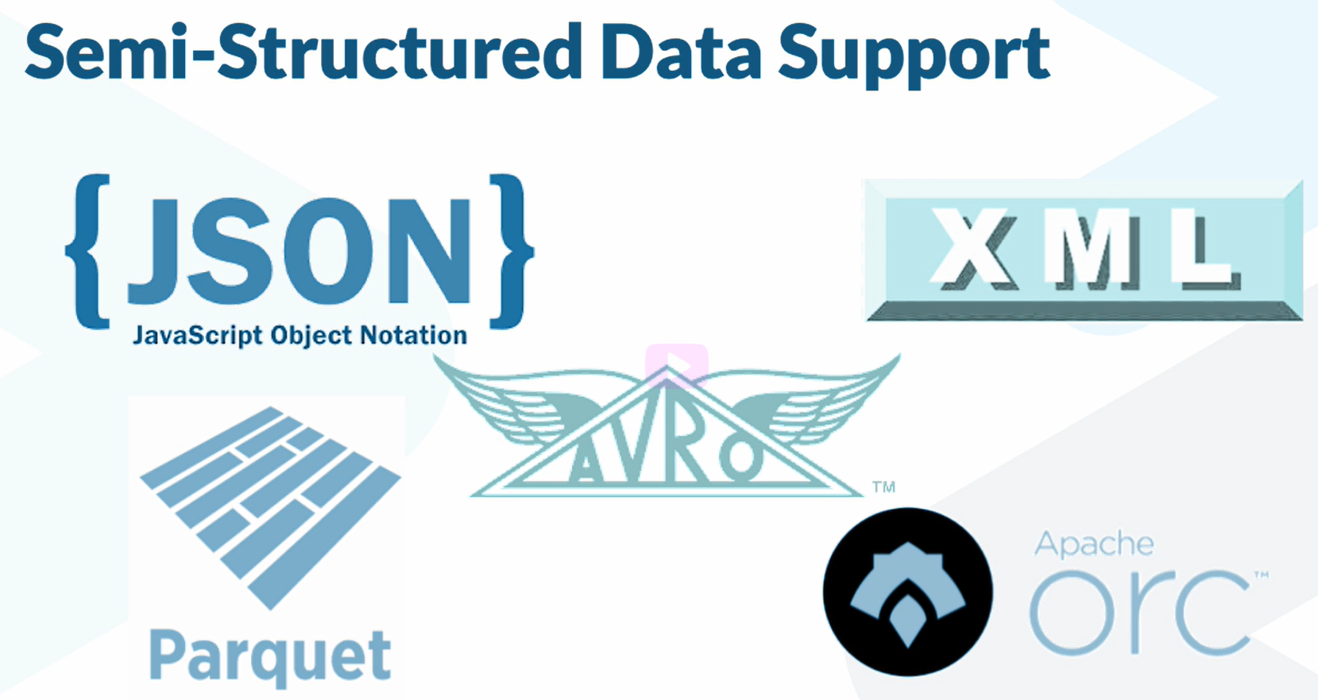

# View:

In the context of **Snowflake**, a **view** is a saved query that presents data from one or more tables in a structured, virtual manner. It does not store data itself but provides a way to query and interact with the underlying data as if it were a table.

**Types of Views in Snowflake:**

1. **Standard View:**
   * A standard view executes the underlying query every time it is accessed.
   * It is dynamic and always reflects the most recent data from the source tables.
2. **Materialized View:**
   * Unlike a standard view, a materialized view stores a physical copy of the data resulting from the query.
   * It can improve performance for queries, especially if the underlying data is large and does not change frequently.
   * However, it consumes additional storage and requires maintenance through **refreshes** to keep it up-to-date.

**Creating a View in Snowflake:**

You can create a view using the SQL CREATE VIEW statement. For example:

**Example: Standard View**

CREATE OR REPLACE VIEW view_name AS

SELECT column1, column2

FROM table_name

WHERE condition;

**Example: Materialized View**

CREATE MATERIALIZED VIEW view_name AS

SELECT column1, column2

FROM table_name

WHERE condition;

**Key Features of Snowflake Views:**

1. **Logical Structure:** Views are logical constructs; they do not store data (except for materialized views).
2. **Reusability:** Simplifies query reuse and helps in modularizing SQL logic.
3. **Security:** You can use views to restrict access to specific columns or rows in a table.
4. **Performance:** Materialized views improve query performance but require more resources and maintenance.

**Use Cases for Views:**

* **Data Abstraction:** Abstract complex joins and transformations for end-users.
* **Security and Compliance:** Provide role-based access to specific columns or rows.
* **Data Aggregation:** Summarize data for reporting and analysis.
* **Data Transformation:** Apply filters or derive computed columns dynamically.

Would you like an example tailored to a specific dataset or scenario?